CSC-390 Senior Project: Isidore
Adam Gignac

Project Statement
Many students use portable computers to take notes in a modern university setting. However, there are very few tools specifically designed with this task in mind; word processors, for example, devote too much attention to formatting and layout - important features for printed documents, but hardly suited to recording a collection of related ideas such as a lecture. Why force users to think in terms of pages and documents, when what they really want are segments of information?
For my senior project, I will create an application that allows students to take and organize notes, gather information related to classes, manage their schedules, and other related functionality. Notes will be automatically tagged and sorted by date, grouped by course, and can be hyperlinked together. Text-based notes, web sources, and tables will be supported.

User Stories
As a student, I want to:
- Input my courses into the application
- View my courses in the sidebar and in a calendar
- Create a new page of notes
- Edit an existing page of notes
- Embed a web source into a note
- Add a table to a note or as a standalone file

Acceptance Tests
The user should be able to:
- Add a new course (collection of notes) [COMPLETE]
- Create a new text note [COMPLETE]
- Create a new table [COMPLETE]
- Embed a table in a text note [COMPLETE]
- Embed a web page in a text note [COMPLETE]
- Embed a Wikipedia page in a text note [COMPLETE]
- View and edit previous notes [COMPLETE]
- Search their notes [COMPLETE]
The software should:
- Automatically mark a note with the date and time it was created [COMPLETE]

Design Norms

Cultural Appropriateness
- The program should make it easier for students to take notes in class, enhancing their education.

Openness and Communication
- The program will be open source, allowing it to be understood by anyone with the desire to learn
- The program will allow a student to get information from a lecturer and store it in such a way that it will be easily accessible and logically structured

Stewardship
- Extensibility: The program will allow new types of note to be added as plugins, allowing it to support future education scenarios
- Economic: The program will provide a free alternative to commercial software such as Microsoft OneNote

Aesthetic
- The software should be visually appealing and present information clearly and simply

Trust
- The software should store notes in a format that will be accessible without needed to use the software, so that notes will not be locked in to the platform
- The software WILL NOT replace proper studying techniques, merely enhance the student's work

References
- HTML Pocket Reference, David Flanagan (O'Reilly Media)
- Javascript Pocket Reference, Jennifer Niederst Robbins (O'Reilly Media)
- GTK documentation (http://www.gtk.org/documentation.php)

SQLite Database Schema
- Table 'course'
  - code TEXT
  - title TEXT
- Table 'note'
  - date TEXT
  - time TEXT
  - course FOREIGN KEY (course)
  - path TEXT

UML Diagrams
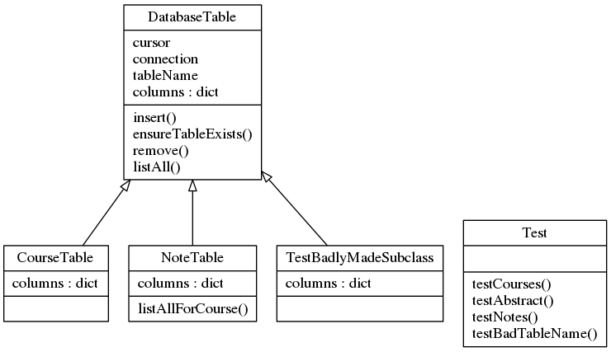
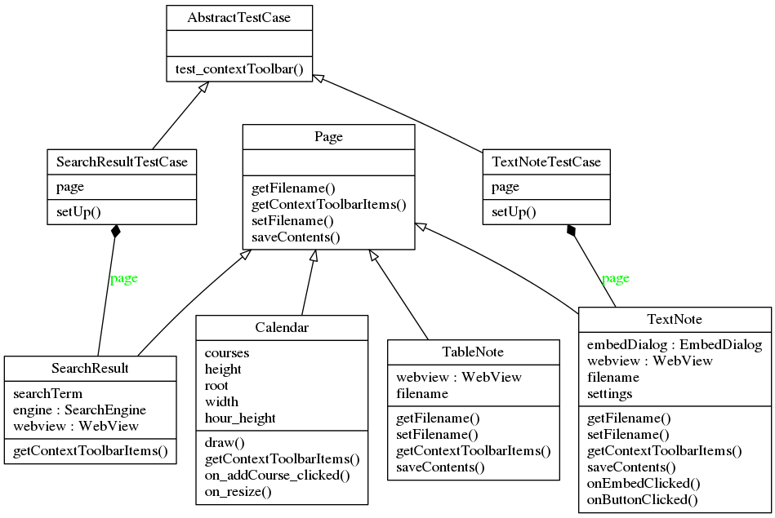
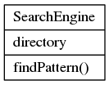
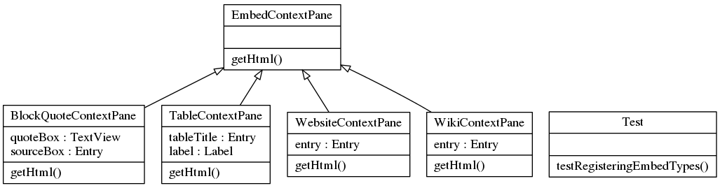
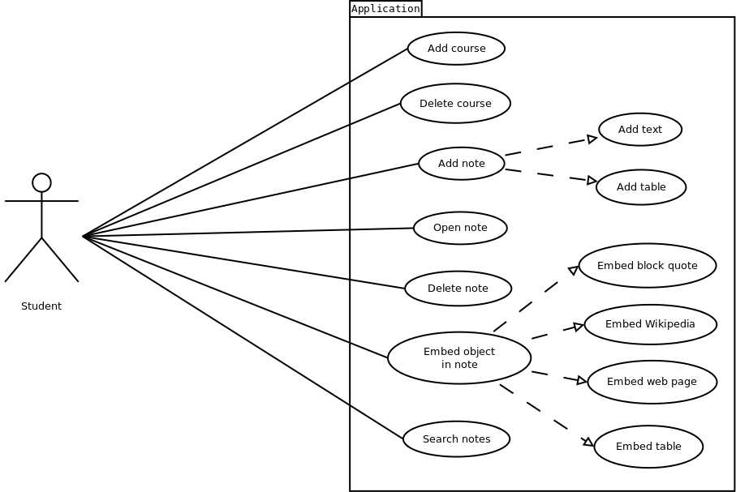

Screenshots
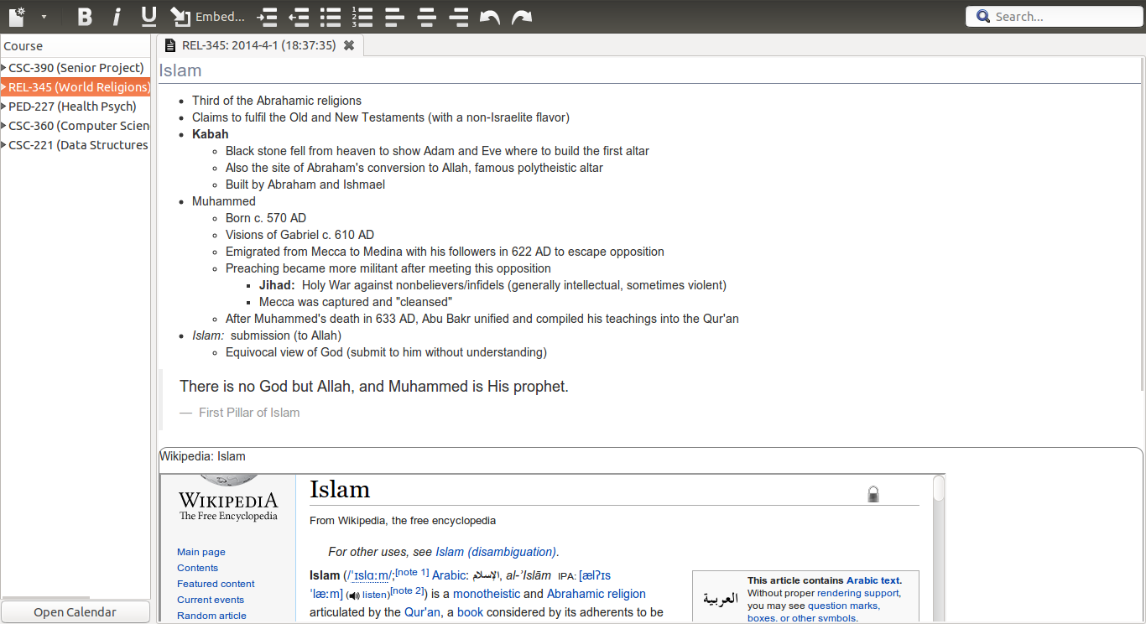
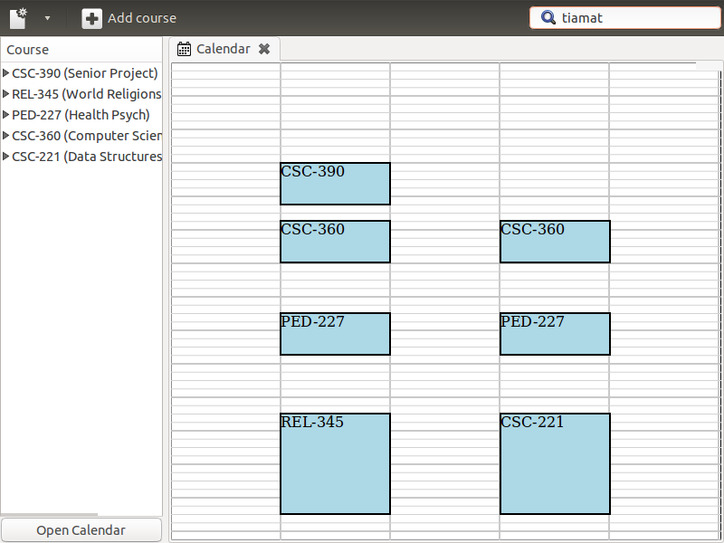
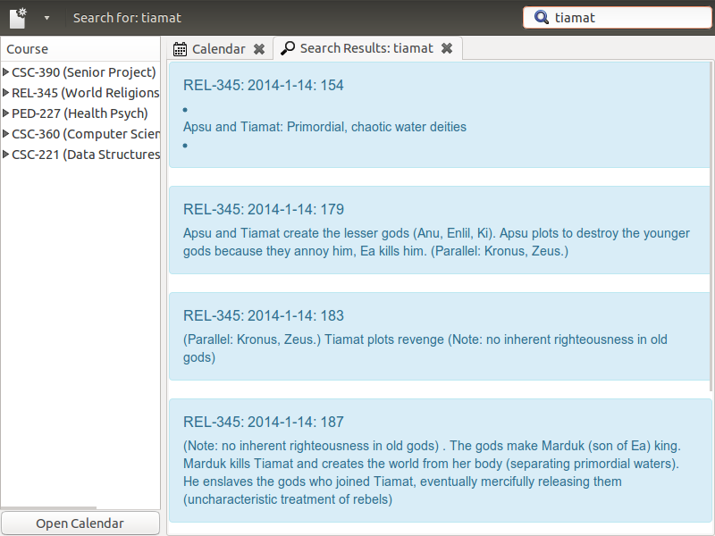

Gantt Chart
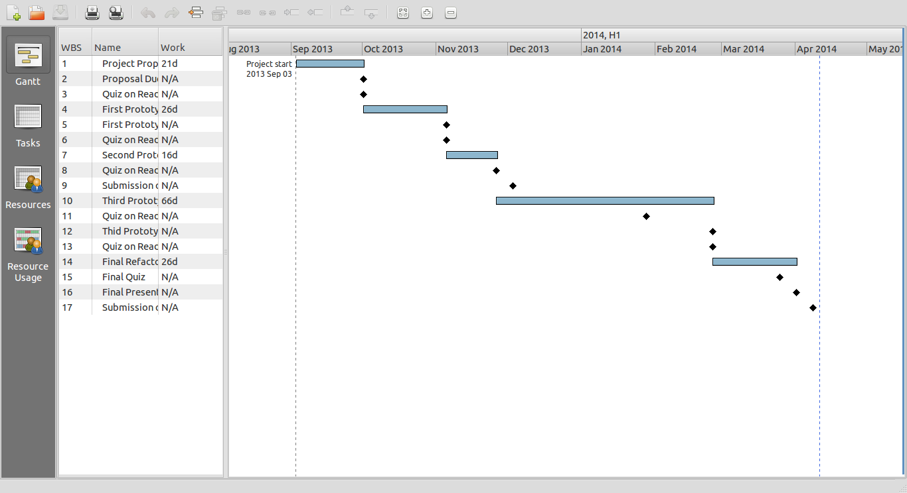

Potential Future Development
- Support videos and pictures
- Allow users to set a PDF textbook for each course and link to it from notes
- User interface improvements
- Improve performance of embedded web sources and/or provide visual feedback while loading them

Conclusions
During the development of this project, I was able to further my understanding of the tools of development: Git, Eclipse/PyDev, PyLint and PyReverse. (On this note, I developed an appreciation for Github as an issue tracker; setting milestones and targetting issues for them helped to keep the project organized.) I experienced the varying stages of planning and of soliciting user input on features they would like to see. My familiarity with unit testing improved from “abysmal” to “passable” - there is still room for much improvement in my test coverage. Personally, I discovered that my motivation levels tend to vary as the project begins to focus more on small details – I'd rather hack than polish.

